Robot Controlled By Android Application

**Rationale**:

Our project proposes a robotic vehicle that can be handled remotely through an android based device. The control device is integrated with a Bluetooth device that allows capturing and reading the commands. The robotic vehicle may then be operated as desired as commanded through the android application. The vehicle is integrated with a microcontroller of 8051 family that is used to operate the vehicle as per android commands.  
The controlling device may be any android based Smartphone/tab etc having an android OS. The android controlling system provides a good interactive GUI that makes it easy for the user to control the vehicle. The transmitter uses an android application required for transmitting the data.

**Features:**

The android device sends commands to move the vehicle in forward, backward, right and left directions.

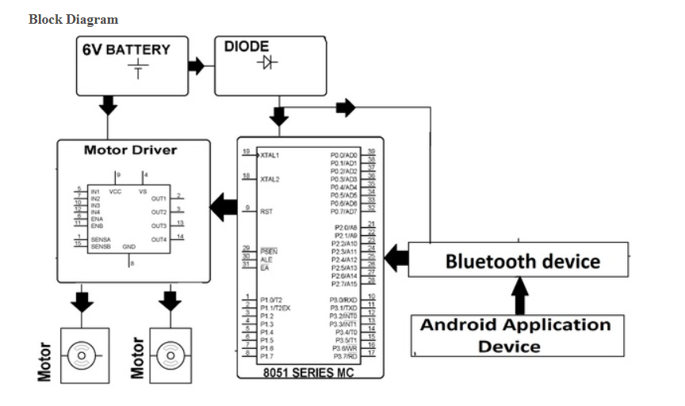

# Fingerprint Vehicle Starter Project

**Rationale:**

Vehicle security is an important issue these days due to the rising number of vehicle thefts. Also one more issue with vehicles is handling its keys. Keys need to be carried and misplacing keys or loosing them will cause a serious issue. Here we propose a solution to this problem by using a fingerprint authenticated vehicle starter system. The system provides a secure and hassle free way to start/stop vehicle engine.

**Features:**

* User just needs to scan finger to start the car, no need to carry any key.
* The system only allows authorized users to start the vehicle.
* Users can first register into the system by scanning fingerprints.

# 

# 3D Holographic Display System With Gesture Controller

**Rationale:**

Hologram makers, render 3D projections whether it’s inside a glass tube or suspended in thin air. 3D multi dimensional images enable users to interact with content in a totally unique way from a 360-degree seeing point. The way to the operation of holographic projectors is the 3D image.

**Features:**

A holographic projector utilizes part illuminations reflected together from multiple viewing angles of the subject in a combined form to reproduce a picture of the subject in a 3D state.

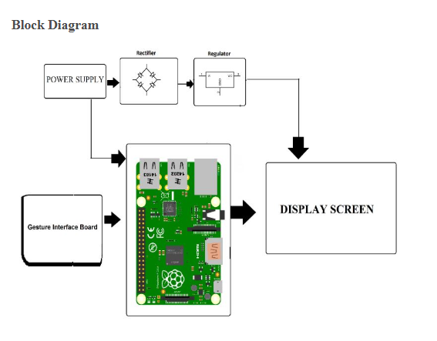

# Face Recognition Door Lock System

**Rationale:**

The most important of feature of any home security system is to detect the people who enter or leave the house. Instead of monitoring that through passwords or pins unique faces can be made use of as they are one’s biometric trait. These are innate and cannot be modified or stolen easily. The level of security can be raised by using face detection. The proposed face recognition door lock security system has been developed to prevent robbery in highly secure areas like home environment with lesser power consumption and more reliable standalone security device for both Intruder detection and for door security.

**Features:**

Whenever the person comes in front of the door, it recognizes the face and if it is registered then it unlocks the door, if the face is not registered it will raise an alarm and clicks a picture and send it on the registered number.

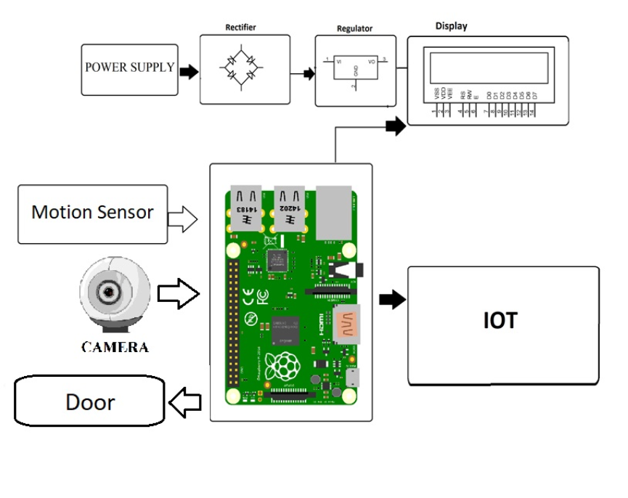

# Android Password Based Remote Door Opener System Project

**Rationale:**

Our project aims at remote password based door opener system through an android application. The system tends to make a secure door opening mechanism such that the door only unlocks when a security personnel opens it by entering the right password through an android application.  
The authorized personnel needs to be present within Bluetooth range of the door but need not open the door manually. He just needs to enter the right password through his android application in order to unlock the door. This is a useful concept in places where the security needs to open gates quite usually or need to operate a door from a vehicle without needing to get down from it.

**Features:**

* The command sending functionality is achieved through an android application.
* As soon as commands are sent through the android device a Bluetooth receiver is used to receive those commands.
* These commands are then sent to the 8051 microcontroller.
* The microcontroller processes these commands and then tallies the password to check its correctness.
* If the right password is encountered it sends command to open the door.

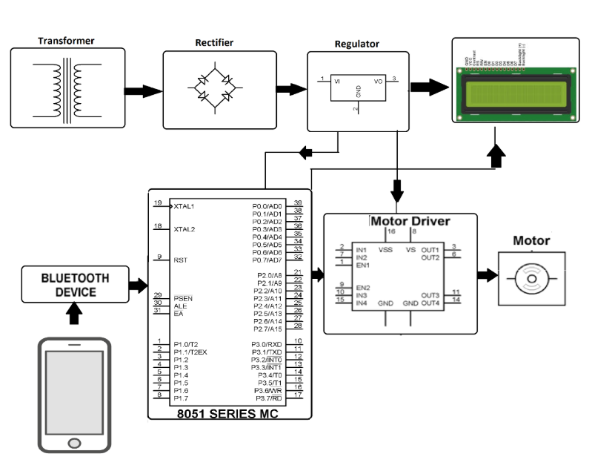

**UNIVERSITY OF CEBU-MAIN CAMPUS**

**COMPUTER ENGINEERING DEPARTMENT**

Osmeña Boulevard Corner Sanciangko Street , Cebu City

NAME : Ahrve Kim E. Jabonillo

DATE : June 21, 2019

TITLE : Robot Controlled By Android Application

Approved

Disapproved

Comments/Suggestions:

_________________________________________________________________________________________________________________________________________________________________________________________________________________________________________________________________________________________________________________________________________________________

**­**____________________________________________________________________________________________

**Evaluators:**

**_______________________________________**

**(Signature over printed name)**

**_______________________________________**

**(Signature over printed name)**

**_______________________________________**

**(Signature over printed name)**

**UNIVERSITY OF CEBU-MAIN CAMPUS**

**COMPUTER ENGINEERING DEPARTMENT**

Osmeña Boulevard Corner Sanciangko Street , Cebu City

NAME : Ahrve Kim E. Jabonillo

DATE : June 21, 2019

# TITLE : Fingerprint Vehicle Starter Project

Approved

Disapproved

Comments/Suggestions:

_________________________________________________________________________________________________________________________________________________________________________________________________________________________________________________________________________________________________________________________________________________________

**­**____________________________________________________________________________________________

**Evaluators:**

**_______________________________________**

**(Signature over printed name)**

**_______________________________________**

**(Signature over printed name)**

**_______________________________________**

**(Signature over printed name)**

**UNIVERSITY OF CEBU-MAIN CAMPUS**

**COMPUTER ENGINEERING DEPARTMENT**

Osmeña Boulevard Corner Sanciangko Street , Cebu City

NAME : Ahrve Kim E. Jabonillo

DATE : June 21, 2019

# TITLE : 3D Holographic Display System With Gesture Controller

Approved

Disapproved

Comments/Suggestions:

_________________________________________________________________________________________________________________________________________________________________________________________________________________________________________________________________________________________________________________________________________________________

**­**____________________________________________________________________________________________

**Evaluators:**

**_______________________________________**

**(Signature over printed name)**

**_______________________________________**

**(Signature over printed name)**

**_______________________________________**

**(Signature over printed name)**

**UNIVERSITY OF CEBU-MAIN CAMPUS**

**COMPUTER ENGINEERING DEPARTMENT**

Osmeña Boulevard Corner Sanciangko Street , Cebu City

NAME : Ahrve Kim E. Jabonillo

DATE : June 21, 2019

# TITLE : Face Recognition Door Lock System

Approved

Disapproved

Comments/Suggestions:

_________________________________________________________________________________________________________________________________________________________________________________________________________________________________________________________________________________________________________________________________________________________

**­**____________________________________________________________________________________________

**Evaluators:**

**_______________________________________**

**(Signature over printed name)**

**_______________________________________**

**(Signature over printed name)**

**_______________________________________**

**(Signature over printed name)**

**UNIVERSITY OF CEBU-MAIN CAMPUS**

**COMPUTER ENGINEERING DEPARTMENT**

Osmeña Boulevard Corner Sanciangko Street , Cebu City

NAME : Ahrve Kim E. Jabonillo

DATE : June 21, 2019

# TITLE : Android Password Based Remote Door Opener System Project

Approved

Disapproved

Comments/Suggestions:

_________________________________________________________________________________________________________________________________________________________________________________________________________________________________________________________________________________________________________________________________________________________

**­**____________________________________________________________________________________________

**Evaluators:**

**_______________________________________**

**(Signature over printed name)**

**_______________________________________**

**(Signature over printed name)**

**_______________________________________**

**(Signature over printed name)**